Health

Room 2051 | 2nd Floor | FF Ribeiro Clinic I East wing, Sammy Marks Building | Cnr Madiba and Sisulu Streets | Pretoria | 0002
PO Box 440 | Pretoria | 0001
Tel: 012 358 8609 / 012 358 4746 | Fax: 012 358 8674
Email: JerryM@tshwane.gov.za | www.tshwane.gov.za | www.facebook.com/CityOf Tshwane

My ref: |  | Tel: 012 358 3216/8
Your ref: |  | Fax: 012 358 0697
Contact person: Lebogang Pelo |  | Email: cehonestop@tshwane.gov.za / lebogangp2@tshwane.gov.za
Section/Unit: Municipal Health Services

Event:  Flair Baby & Toddler Market | Event Date:
Trade Name: | Telephone Number:
Physical Address:
Applicant:

This Division has no objection to the abovementioned application on condition that –

1. MEAT AND MEAT PRODUCTS
Only meat, offal and processed meat of animals slaughtered and approved for human consumption at an approved abattoir, as defined in Part II of the Regulations promulgated in terms of the Abattoir Hygiene Act, 1992 (Act 121 of 1992), as amended by Government Notice R2322 of 14 August 1992, may be kept and offered for sale. Only meat of poultry or rabbits which has been examined and slaughtered in terms of the provisions of the Abattoir Hygiene Act, 1992 (Act 121 of 1992), read with Government Notice R676 of 23 April 1993, and which shows no lesion or disease may be kept or offered for sale. Such meat must be marked on the carcass or on the wrapping in terms of section 4(1) of Government Notice R676 of 23 April 1992.All meat, meat products and processed food that are sold must be provided with a label bearing the name, address and telephone number of the manufacturer, or alternatively, the purchaser must be issued with a purchase voucher containing the said particulars.
2. PASTEURISED MILK
Pasteurised milk may only be obtained from licensed suppliers authorized by the City of Tshwane Metropolitan Municipality to distribute milk within the municipal area of Tshwane. Pasteurised milk must meet the relevant requirements as defined in the Foodstuffs, Cosmetics and Disinfectants Act, 1972 (Act 54 of 1972), the Agriculture Products Standards Act, 1990 (Act 119 of 1990) and the regulations published in terms thereof.
3. GENERAL
3.1 TEMPERATURE
Perishable foods must be kept cooled (7 and lower) or heated (65 or higher.)
3.2 FOOD PROTECTION
Unprotected food must be protected from pollution or contamination where required.
3.3 FOOD HANDLING
Sufficient apparatus and equipment must be available for the hygienic handling of food. Processing and storage must take place in a satisfactory manner.
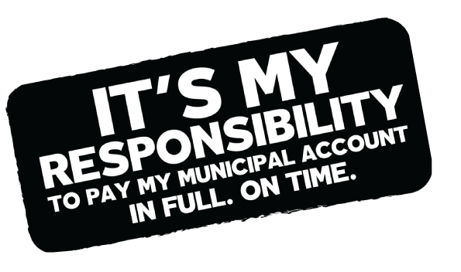
Cooked and raw food must be handled and stored separately. Ice-cream and meat/fish must be stored separately.

3.4 SORES/WOUNDS/CONTAGIOUS DISEASES
Food handlers must not have open sores/wounds or these must be bandaged in such a manner that food cannot be contaminated. No food handler suffering from a disease in the infectious stage or who is a carrier of a disease that can be transmitted by food may handle food.
3.5 NAILS/HANDS
Nails must be short, clean and free from nail polish. Hands/forearms must be clean and free from jewellery.
3.6 CLOTHES
Clothes must be clean, whole and suitable for the specified activity.
3.7 SMOKING
Nobody may smoke in a food preparation area or during the preparation of food.
3.8 DAMAGED EQUIPMENT/APPARATUS
All chopping-boards, pots, pans, crockery, etc must be undamaged, easy to clean and manufactured from a non-toxic material.
3.9 EQUIPMENT/APPARATUS
All equipment and apparatus must be kept clean.
3.10 LIGHTING
Sufficient lighting must be available for the preparation of food and for the cleaning process.
3.11 VENTILATION
As prescribed by the National Building Regulations.
3.12 WATER
An adequate supply of clean water must be available for the cleaning of facilities and the washing of hands.
3.13 WASH-UP FACILITIES
Proper wash-up facilities must be provided.
3.14 SOAP
Soap must be available for the cleaning of accessories and hands.
3.15 RUBBISH REMOVAL
Rubbish must be stored or removed in such a manner that no nuisance is caused.
3.16 WASTE WATER DISPOSAL
Waste water must be disposed of in a suitable manner.
3.17 PEST CONTROL
No flies, cockroaches, rodents etc or signs thereof, may be present on the premises.
3.18 TOILET FACILITIES
Toilet facilities must be available in accordance with the National Building Regulations, if required,
In the case of hawkers, written consent for the use of an accessible toilet will be acceptable.
3.19 SPOILT FOOD
No spoilt food, blown tins, etc may be offered for sale.
3.20 HYGIENE PROGRAMME
A satisfactory programme must be followed for the cleaning of the premises/facilities.
3.21 DUST CONTROL
Adequate dust control measures must be taken.

UNDERTAKING:

I, , the undersigned, ID Number ,
hereby undertake to abide by the above conditions as laid down by the Division Environmental Health.

** A copy of this undertaking and valid trade license must be available at the trading site during the event
for inspection purposes.

___________________________________
SIGNATURE OF APPLICANT Date

On request, this document can be provided in another official language.

